ADITYA UNIVERSITY
Surampalem
Department of Artificial Intelligence & Machine Learning
DBMS CAPSTONE PROJECT
Project Documentation Report
Project Title: Software Development Project Management System
Submitted by:
S.No | Student Name | Roll Number
1 | T. Ruthika TriNayani | 25B11AIC02
2 | A. Keerthi | 25B11AI025
3 | G.K L S Shravya | 25B11AI319
4 | K. Devi Saranya | 25B11AI623
Course: Database Management Systems (DBMS) Course Code: —
Faculty Coordinator: T. Srinivasulu
Academic Year: 2026 Date of Submission: —
GitHub Repository Link: [ Add repository link ]

TABLE OF CONTENTS
TABLE OF CONTENTS 1
1. ABSTRACT 1
2. INTRODUCTION 1
2.1 Background 1
2.2 Purpose of the Database 1
3. PROBLEM STATEMENT 1
4. OBJECTIVES 1
5. TOOLS & TECHNOLOGIES USED 1
6. DATABASE DESIGN 1
6.1 Identified Entities 1
6.2 Entity Attributes 1
6.3 ER Diagram 1
6.4 Relationships & Cardinality 1
6.5 Relational Database Schema 1
6.6 Normalization 1
7. DATABASE IMPLEMENTATION 1
7.1 DDL — Database and Table Creation 1
7.2 Sample Data — DML 1
7.3 Constraints & Data Integrity 1
PRIMARY KEY — evidence 1
FOREIGN KEY — evidence 1
NOT NULL — evidence 1
UNIQUE — evidence 1
CHECK — evidence 1
DEFAULT — evidence 1
7.4 SQL Operations & Queries 1
7.5 Sample Outputs / Screenshots 1
8. MODULES & FUNCTIONALITIES 1
9. GITHUB REPOSITORY & TEAM RESPONSIBILITIES 1
10. ENHANCEMENTS & FUTURE IMPROVEMENTS 1
11. CONCLUSION 1
12. REFERENCES 1
APPENDIX 1
A. Complete SQL Script 1
B. Additional Screenshots / Outputs 1

1. ABSTRACT
The Software Development Project Management System is a centralized relational database developed to manage client projects, teams, developers, tasks and bugs efficiently. It stores and organizes information related to clients, projects, teams, developers, modules, tasks, and bugs so that every task and bug can be traced back to the client project it belongs to.
The system replaces disconnected spreadsheets that previously caused duplicated effort, missed deadlines and lost bug reports. It uses SQL operations and database constraints — primary keys, foreign keys, NOT NULL, UNIQUE, CHECK and DEFAULT — to maintain data accuracy, consistency and referential integrity across all seven tables.

2. INTRODUCTION

2.1 Background
Development teams commonly track projects, tasks and bugs in disconnected spreadsheets. This causes duplicated effort, missed deadlines and lost bug reports, because there is no single source of truth linking a client's project to its modules, tasks, developers and bugs.
Maintaining task progress and bug status manually across spreadsheets is also time-consuming and error-prone. A centralized database system is therefore useful for organizing project-management information and making it easier to track and retrieve.

2.2 Purpose of the Database
The main purpose of the database is to provide a centralized system for storing and managing software project data end-to-end, from client onboarding to bug resolution.
The database helps to:
- Maintain client and project records.
- Organize teams, developers and their module/task assignments.
- Track task progress from assignment to completion.
- Record and monitor bugs from report to resolution.
- Support reports such as developer workload, project status and open bugs per module.
- Reduce duplicate data and improve accuracy through well-defined keys and constraints.

3. PROBLEM STATEMENT
Development teams track projects, tasks and bugs in disconnected spreadsheets, causing duplicated effort, missed deadlines and lost bug reports. There is no single source of truth linking a client's project to its modules, tasks, developers and bugs.
Preparing reports such as developer workload or open bugs per module becomes difficult when information is stored separately. Therefore, a centralized relational database is needed to store and manage project-management information efficiently, accurately and with clear, queryable relationships.

4. OBJECTIVES
- Objective 1: Design a normalized database for clients, projects, teams, developers, modules, tasks and bugs.
- Objective 2: Model relationships between projects, teams, tasks and bugs with correct cardinalities.
- Objective 3: Track task progress and bug status from assignment to resolution.
- Objective 4: Support reports such as developer workload, project status and open bugs per module.
- Objective 5: Ensure data integrity through well-defined primary and foreign keys.

5. TOOLS & TECHNOLOGIES USED
Category | Tool / Technology Used
Database Server | PostgreSQL
Query / Admin Tool | pgAdmin / DB Fiddle
Front-end (if any) | None
Operating System | Windows
Version Control | GitHub

6. DATABASE DESIGN

6.1 Identified Entities
7 entities were identified to model the project-management domain:
S.No | Entity Name | Description
1 | Client | Stores information about clients who commission projects.
2 | Project | Stores project details commissioned by a client.
3 | Team | Stores the single team assigned to a project.
4 | Developer | Stores information about developers who belong to a team.
5 | Module | Stores the functional modules that make up a project.
6 | Task | Stores tasks within a module, assigned to a developer.
7 | Bug | Stores bugs reported against a task.

6.2 Entity Attributes
Attributes of each entity, with Primary Keys (PK) and Foreign Keys (FK) marked:
Entity | Attribute | Data Type | Key
Client | client_id | INT | PK
Client | name, email, phone, address | VARCHAR | —
Project | project_id | INT | PK
Project | title | VARCHAR(100) | —
Project | client_id | INT | FK → Client
Project | start_date, end_date | DATE | —
Project | status | VARCHAR(20) | —
Team | team_id | INT | PK
Team | team_name | VARCHAR(100) | —
Team | project_id | INT | FK → Project
Developer | developer_id | INT | PK
Developer | name, email, role | VARCHAR | —
Developer | team_id | INT | FK → Team
Module | module_id | INT | PK
Module | module_name, description | VARCHAR | —
Module | project_id | INT | FK → Project
Task | task_id | INT | PK
Task | title, deadline, status | VARCHAR / DATE | —
Task | module_id | INT | FK → Module
Task | developer_id | INT | FK → Developer
Bug | bug_id | INT | PK
Bug | description, severity, status, reported_date | VARCHAR / DATE | —
Bug | task_id | INT | FK → Task

6.3 ER Diagram
The ER diagram below shows all 7 entities, their attributes, and the relationships that connect them.
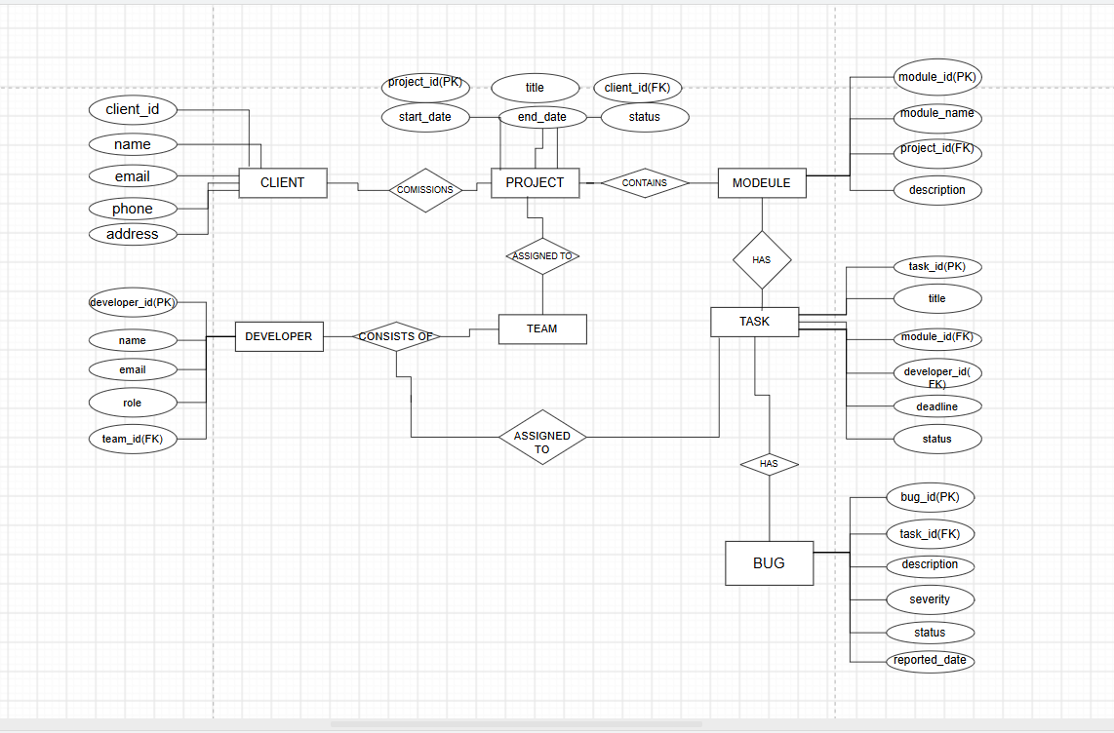
Figure: Entity-Relationship diagram of the Software Development Project Management System.

6.4 Relationships & Cardinality
Entity 1 | Relationship | Entity 2 | Cardinality
Client | commissions | Project | 1 : M
Project | has / contains | Module | 1 : M
Project | assigned to | Team | 1 : 1
Team | consists of | Developer | 1 : M
Module | contains | Task | 1 : M
Developer | assigned to | Task | 1 : M
Task | has / reports | Bug | 1 : M

6.5 Relational Database Schema
The relational schema below lists every table, its columns and the primary/foreign key relationships between them, as finalized in Review I.
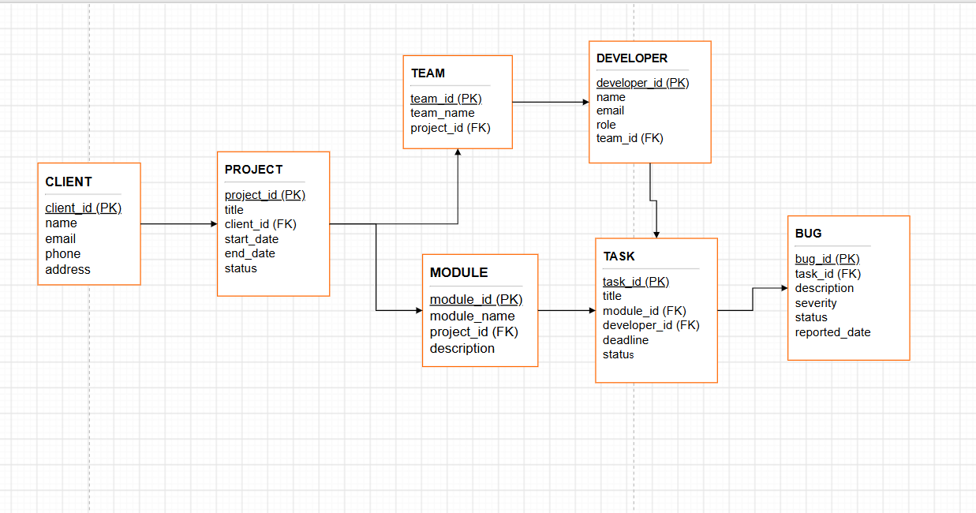
Figure: Relational database schema — 7 tables and 8 foreign keys.

6.6 Normalization
UNF → 1NF → 2NF → 3NF
Normalization is used to reduce data redundancy and avoid insert, update and delete anomalies in the Software Development Project Management System.
The database is normalized by separating data into related tables: Client, Project, Team, Developer, Module, Task and Bug — instead of storing everything (e.g. a client's projects, a project's modules, and a module's tasks) in one flat table.
Normalization steps:
- 1NF: Every attribute holds a single, atomic value and there are no repeating groups (e.g. a project stores one status, not a list).
- 2NF: All non-key attributes depend on the whole primary key — each table's primary key is a single column, so this holds by construction.
- 3NF: Non-key attributes depend only on the primary key and not on other non-key attributes (e.g. a developer's team_id is stored once on Developer, not repeated on every Task).
Applicable Normal Form: 3NF
The database design follows Third Normal Form (3NF), which reduces duplicate data and improves data consistency. Relationships between tables are maintained using Primary Keys (PKs) and Foreign Keys (FKs), giving 8 foreign keys across the 7 tables.

7. DATABASE IMPLEMENTATION

7.1 DDL — Database and Table Creation
The database and all 7 tables were created with the script below, including PRIMARY KEY, FOREIGN KEY, NOT NULL, UNIQUE, CHECK and DEFAULT constraints.
CREATE DATABASE pms_db;
-- connect to the new database before creating tables
-- (psql: \c pms_db; pgAdmin: select pms_db from the browser)
CREATE TABLE Client (
client_id INT PRIMARY KEY,
name VARCHAR(100) NOT NULL,
email VARCHAR(100) NOT NULL UNIQUE,
phone VARCHAR(15),
address VARCHAR(200)
);
CREATE TABLE Project (
project_id INT PRIMARY KEY,
title VARCHAR(100) NOT NULL,
client_id INT NOT NULL,
start_date DATE,
end_date DATE,
status VARCHAR(20) DEFAULT 'Ongoing'
CHECK (status IN ('Ongoing','Completed','On Hold')),
FOREIGN KEY (client_id) REFERENCES Client(client_id)
);
CREATE TABLE Team (
team_id INT PRIMARY KEY,
team_name VARCHAR(100) NOT NULL,
project_id INT NOT NULL,
FOREIGN KEY (project_id) REFERENCES Project(project_id)
);
CREATE TABLE Developer (
developer_id INT PRIMARY KEY,
name VARCHAR(100) NOT NULL,
email VARCHAR(100) NOT NULL UNIQUE,
role VARCHAR(50),
team_id INT NOT NULL,
FOREIGN KEY (team_id) REFERENCES Team(team_id)
);
CREATE TABLE Module (
module_id INT PRIMARY KEY,
module_name VARCHAR(100) NOT NULL,
description VARCHAR(200),
project_id INT NOT NULL,
FOREIGN KEY (project_id) REFERENCES Project(project_id)
);
CREATE TABLE Task (
task_id INT PRIMARY KEY,
title VARCHAR(100) NOT NULL,
deadline DATE,
status VARCHAR(20) DEFAULT 'Pending'
CHECK (status IN ('Pending','In Progress','Completed')),
module_id INT NOT NULL,
developer_id INT NOT NULL,
FOREIGN KEY (module_id) REFERENCES Module(module_id),
FOREIGN KEY (developer_id) REFERENCES Developer(developer_id)
);
CREATE TABLE Bug (
bug_id INT PRIMARY KEY,
description VARCHAR(200) NOT NULL,
severity VARCHAR(10) CHECK (severity IN ('Low','Medium','High')),
status VARCHAR(20) DEFAULT 'Open'
CHECK (status IN ('Open','Resolved')),
reported_date DATE,
task_id INT NOT NULL,
FOREIGN KEY (task_id) REFERENCES Task(task_id)
);
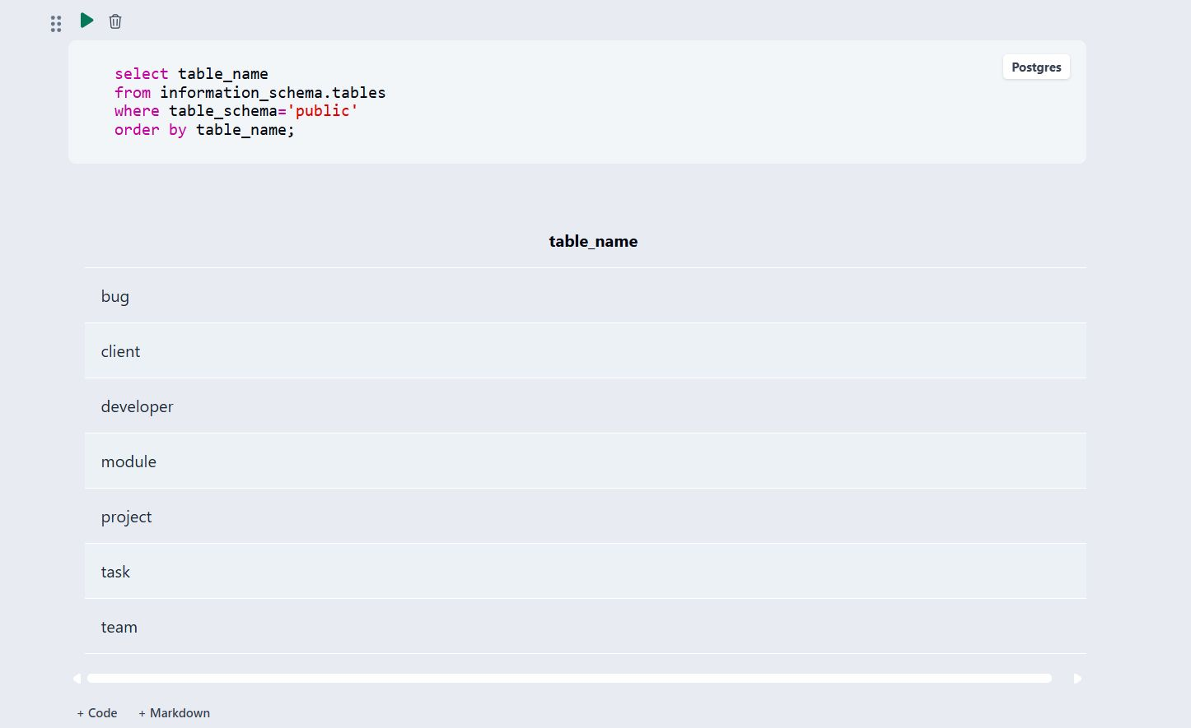
Figure 1: All 7 tables created in pms_db (PostgreSQL).

7.2 Sample Data — DML
Sample data was inserted into all 7 tables:
Table | Records | Notes
Client | 2 | One client per sample project
Project | 2 | 1 Ongoing, 1 Completed
Team | 2 | One team per project (1:1)
Developer | 4 | 2 developers per team
Module | 4 | 2 modules per project
Task | 6 | Linked to modules & developers
Bug | 4 | Linked to tasks, mixed severity
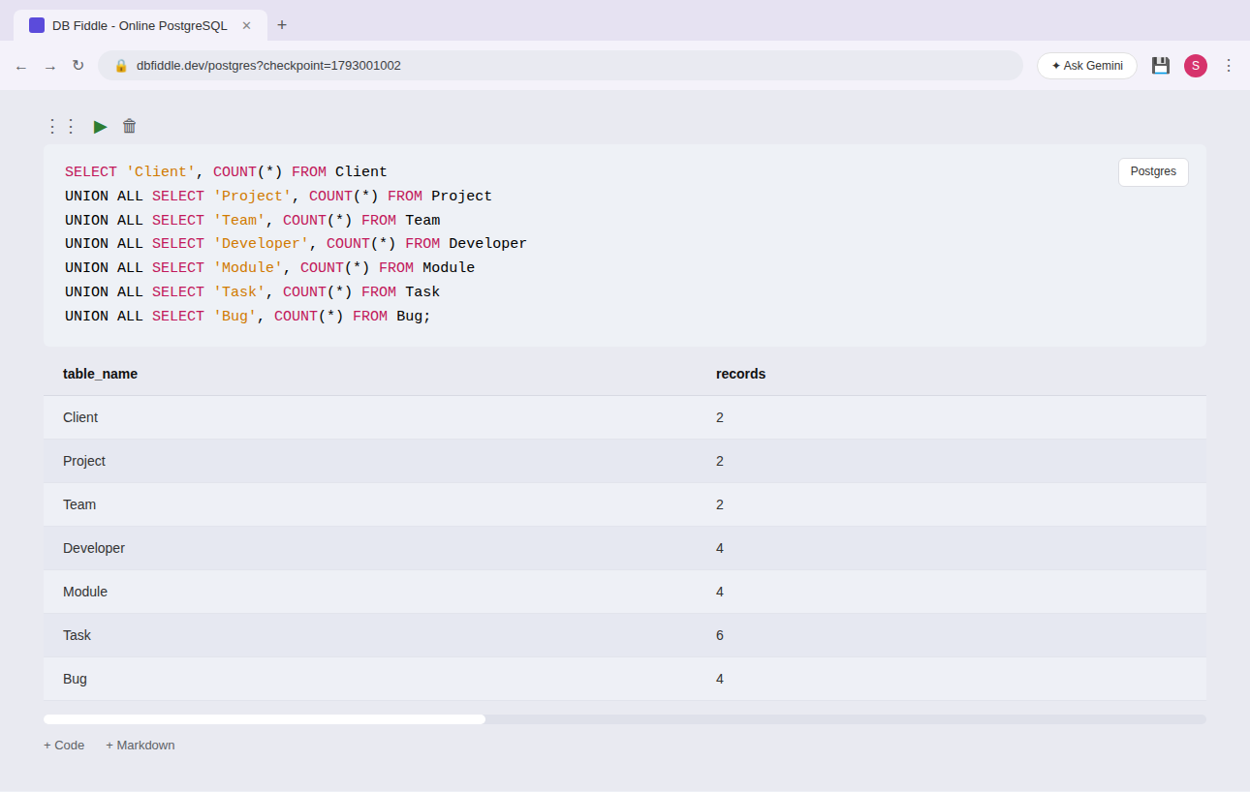
Figure 2: Record counts confirming sample data in all 7 tables.
Sample INSERT statement (Task and its linked Bug):
INSERT INTO Task
(task_id, title, module_id, developer_id, deadline, status)
VALUES
(502, 'Build stock update API', 401, 301, '2026-02-15', 'In Progress');
INSERT INTO Bug
(bug_id, task_id, description, severity, status, reported_date)
VALUES
(601, 502, 'Stock count goes negative on bulk update',
'High', 'Open', '2026-02-18');
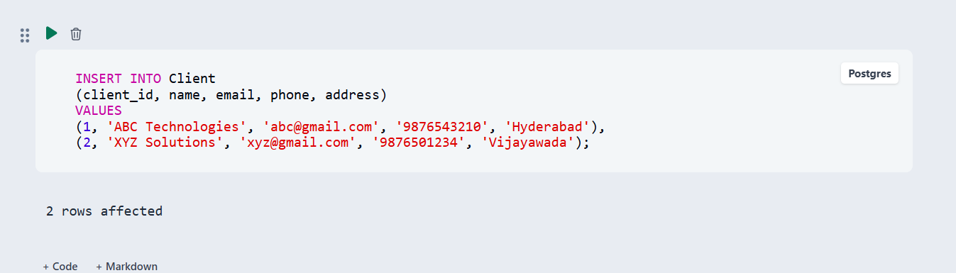

Figure: Sample Task and Bug rows inserted (2 rows affected).

7.3 Constraints & Data Integrity
The following constraints were applied to keep project-management data accurate and consistent:
Constraint | Applied On | Purpose
PRIMARY KEY | *_id columns (all 7 tables) | Prevents duplicate IDs in every table
FOREIGN KEY | client_id, project_id, team_id, module_id, developer_id, task_id | Maintains valid relationships between tables (8 FKs total)
NOT NULL | name, title, description | Prevents missing required values
UNIQUE | Client.email, Developer.email | Prevents duplicate emails
CHECK | Project.status, Task.status, Bug.severity, Bug.status | Restricts values to a valid, predefined set
DEFAULT | Project.status, Task.status, Bug.status | Auto-fills a sensible status when not supplied

PRIMARY KEY — evidence
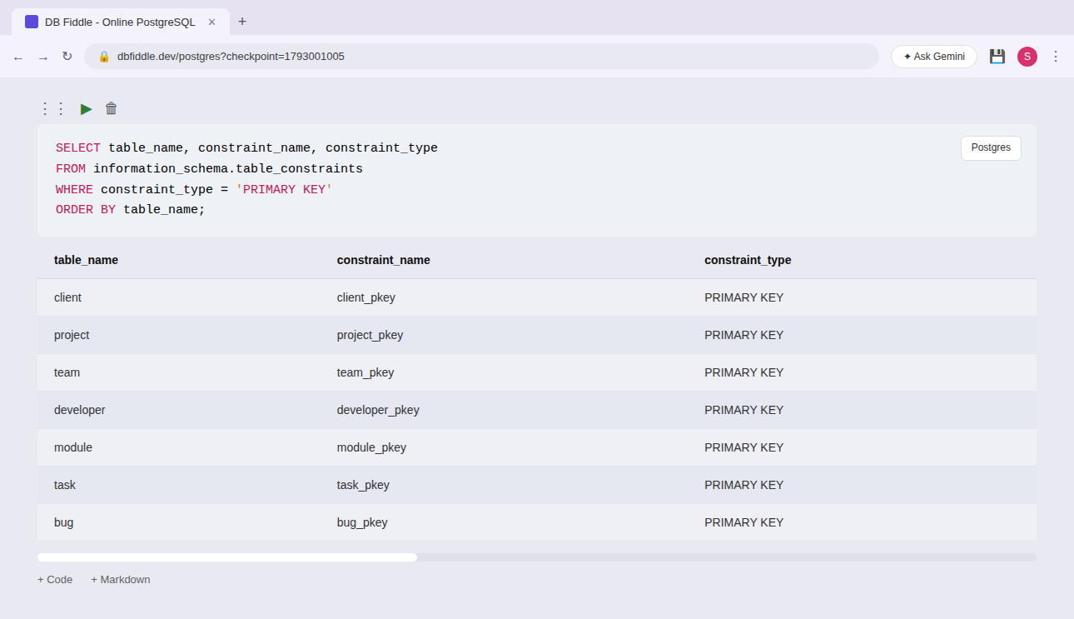
Figure: PRIMARY KEY constraint in effect.

FOREIGN KEY — evidence

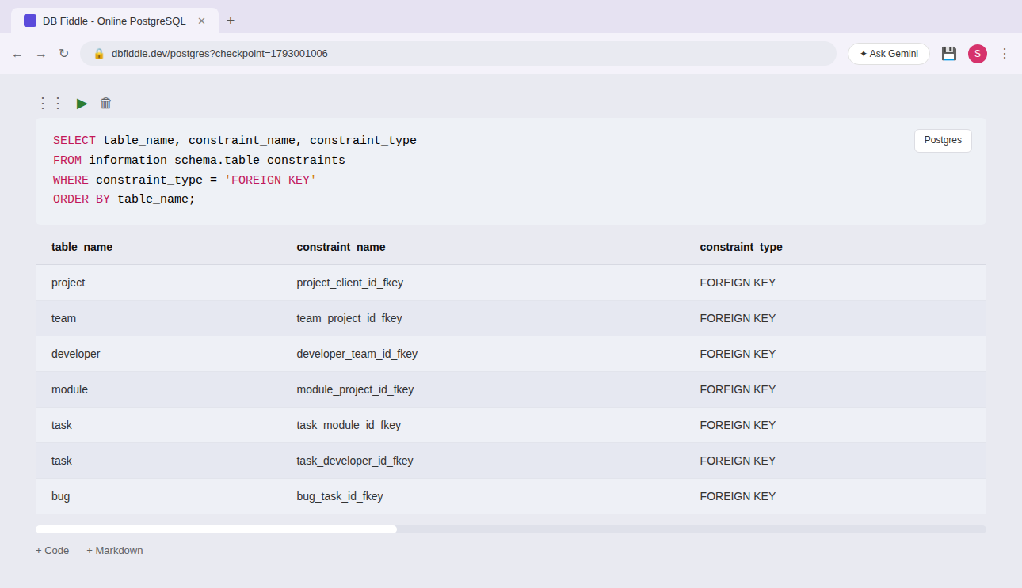
Figure: FOREIGN KEY constraint in effect.

NOT NULL — evidence

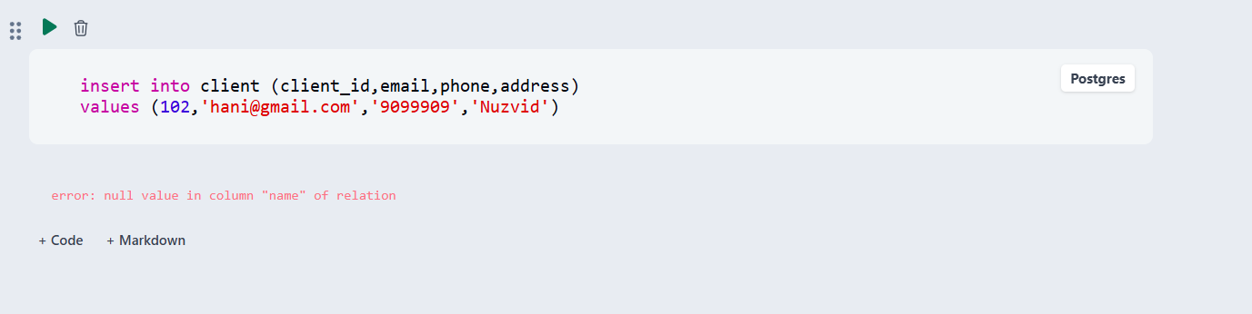

Figure: NOT NULL constraint in effect.

UNIQUE — evidence

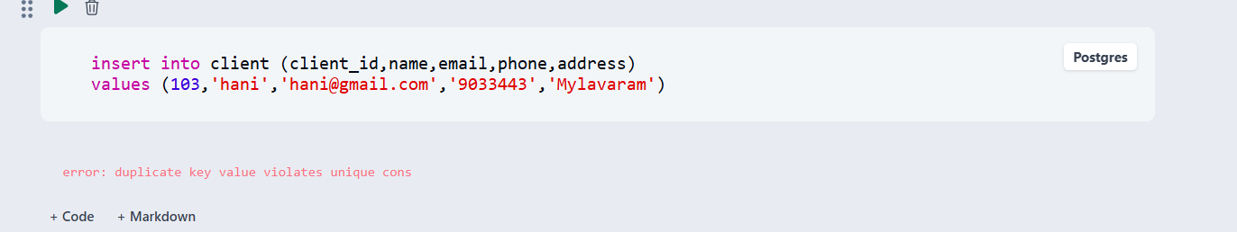

Figure: UNIQUE constraint in effect.

CHECK — evidence
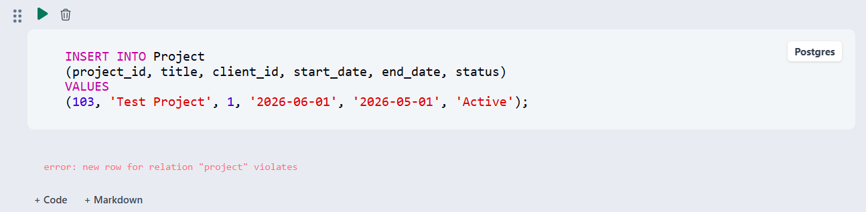

Figure: CHECK constraint in effect.

DEFAULT — evidence
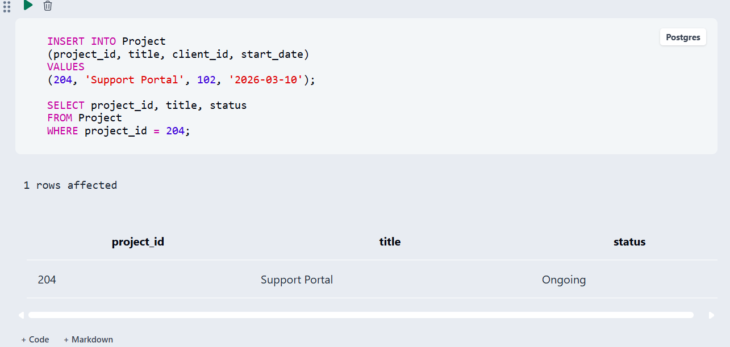

Figure: DEFAULT constraint in effect.

7.4 SQL Operations & Queries
Representative DDL, DML, DQL, CRUD, JOIN, aggregate and VIEW operations used in the project:
S.No | Operation / Query | Purpose | SQL Query
1 | DDL — ALTER TABLE | Adds a new column to Developer | ALTER TABLE Developer ADD COLUMN phone VARCHAR(15);
2 | DDL — DROP TABLE | Removes a temporary table | DROP TABLE IF EXISTS TempLog;
3 | DML — UPDATE | Marks a task as completed | UPDATE Task SET status='Completed' WHERE task_id = 502;
4 | DML — DELETE | Removes a resolved bug | DELETE FROM Bug WHERE bug_id = 604;
5 | DQL — SELECT / WHERE | Lists tasks that are not yet completed | SELECT title, status FROM Task WHERE status <> 'Completed';
6 | CRUD — JOIN | Tasks assigned to each developer | SELECT d.name, t.title, t.status FROM Developer d JOIN Task t ON d.developer_id = t.developer_id ORDER BY d.name;
7 | Aggregate — GROUP BY | Task count per developer (workload) | SELECT d.name, COUNT(t.task_id) AS total_tasks FROM Developer d LEFT JOIN Task t ON d.developer_id = t.developer_id GROUP BY d.name;
8 | Aggregate — GROUP BY | Open bugs per module | SELECT m.module_name, COUNT(b.bug_id) AS open_bugs FROM Module m JOIN Task t ON m.module_id = t.module_id JOIN Bug b ON t.task_id = b.task_id WHERE b.status='Open' GROUP BY m.module_name;
9 | Aggregate — GROUP BY | Bugs grouped by severity | SELECT severity, COUNT(*) AS bug_count FROM Bug GROUP BY severity ORDER BY bug_count DESC;
10 | VIEW | Reusable developer workload report | CREATE VIEW DeveloperWorkload AS SELECT d.name, COUNT(t.task_id) AS active_tasks FROM Developer d JOIN Task t ON d.developer_id=t.developer_id WHERE t.status<>'Completed' GROUP BY d.name;
Explanation: DDL changes table structure, DML changes stored data, and DQL retrieves data without modifying it. The JOIN links Developer and Task on developer_id so each task shows its owner; GROUP BY queries then aggregate results into project-management insights (workload, open bugs per module, severity breakdown); and the VIEW packages the workload report as a reusable, named query.
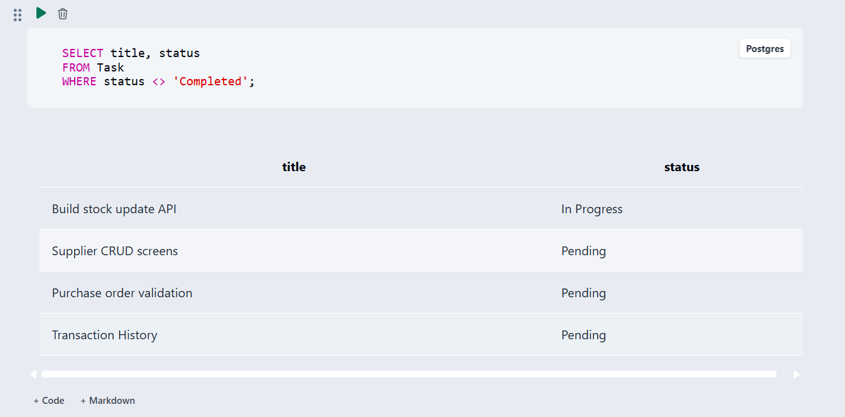

Figure: Open / in-progress tasks.
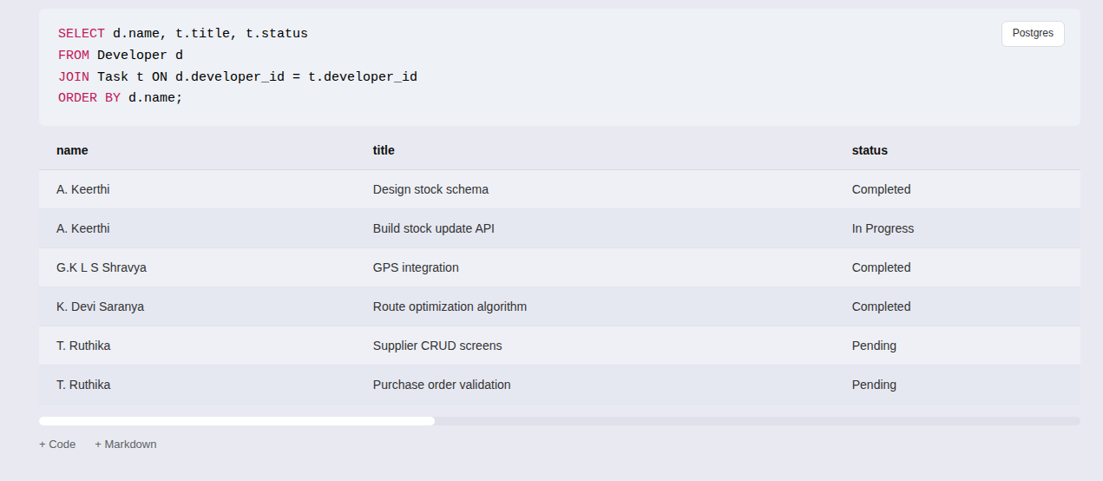
Figure: Tasks assigned to each developer (JOIN).
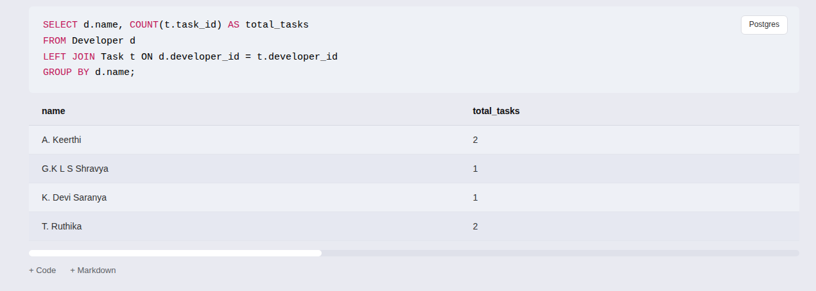
Figure: Task count per developer (LEFT JOIN + GROUP BY).
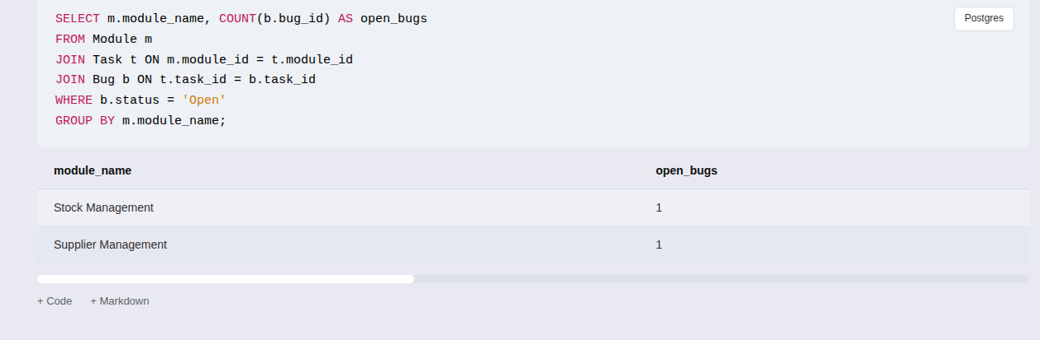
Figure: Open bugs per module.
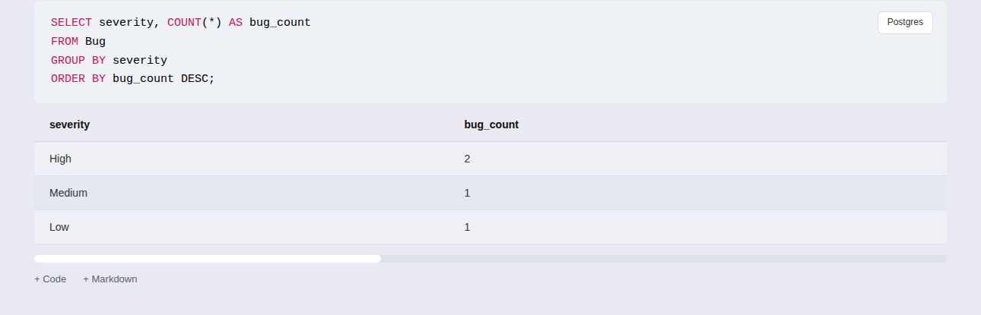
Figure: Bugs grouped by severity.
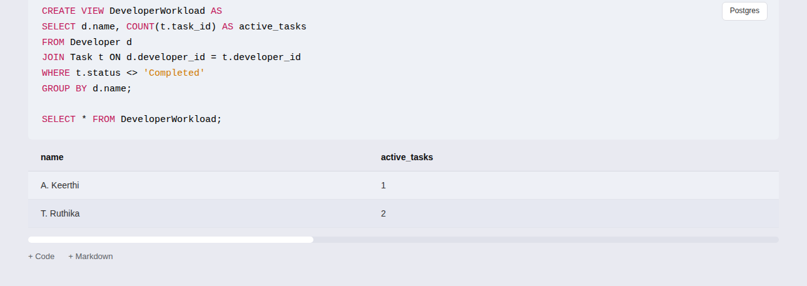
Figure: DeveloperWorkload view — example output.

7.5 Sample Outputs / Screenshots
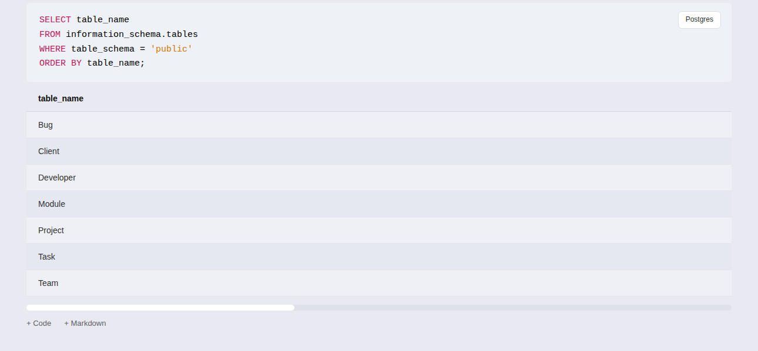
Figure 1: Database and table creation in PostgreSQL / pgAdmin.
Figure 2: Sample data inserted into Client, Project, Team, Developer, Module, Task and Bug.

Figure 3: Details of Client.
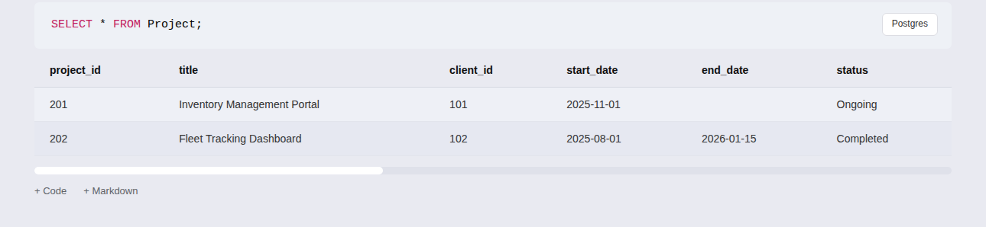
Figure 4: Details of Project.

8. MODULES & FUNCTIONALITIES
S.No | Module Name | Functionality
1 | Client Management | Stores and manages client details such as client ID, name, email, phone, and address.
2 | Project Management | Maintains project information including project ID, title, client, start/end dates and status.
3 | Team Management | Manages the team assigned to each project (team ID, team name, project).
4 | Developer Management | Stores developer information including developer ID, name, email, role, and team.
5 | Module Management | Manages the functional modules of a project (module ID, name, description, project).
6 | Task Management | Records tasks within a module, their deadline and status, and the developer assigned.
7 | Bug Management | Tracks bugs reported against a task, including severity, status and report date.

9. GITHUB REPOSITORY & TEAM RESPONSIBILITIES
Repository Link: [ Add repository link ]
Student Name | Roll Number | Responsibility | Status
T.Ruthika | 25B11AIC02 | ER Diagram,and relational schema | Completed
K. Devi Saranya | 25B11AI623 | DDL,Tables,keys,constraints | Completed
A.Keerthi | 25B11AI025 | (DML) & SQL queries | Completed
G. Shravya | 25B11AI319 | Documentation, screenshots | Completed

10. ENHANCEMENTS & FUTURE IMPROVEMENTS
The Software Development Project Management System can be further enhanced to improve usability, security and reporting. The following improvements are planned:
- Role-Based Access: Separate login and permissions for clients, developers and project managers.
- Deadline Notifications: Automated reminders for approaching task deadlines and unresolved bugs.
- Reporting Dashboard: A visual dashboard summarizing project status, developer workload and open bugs.
- User Interface Integration: A web-based interface so clients and developers can access the system directly.
- Performance Improvements: Indexing and query optimization as the number of projects and tasks grows.
- Scalability: Support for multiple teams per project and multi-level task dependencies.

11. CONCLUSION
The Software Development Project Management System provides a centralized database for managing client projects, teams, developers, modules, tasks and bugs in an organized manner. Database design was finalized with 7 entities, 7 relationships, and a normalized relational schema (3NF).
SQL implementation was completed with DDL, DML and DQL across all tables, and sample data was inserted and validated with consistent foreign keys. CRUD operations, JOIN and aggregate queries, and a reusable VIEW were successfully demonstrated.
Data integrity is maintained through primary keys, foreign keys, and CHECK/UNIQUE/DEFAULT constraints, which together prevent duplicate records, invalid values, missing required data, and broken relationships between tables.
Key learning: translating an ER model into a working, query-ready relational database. Future enhancements include role-based access, deadline notifications, and a reporting dashboard.

12. REFERENCES
- PostgreSQL Documentation — https://www.postgresql.org/docs/
- PostgreSQL SQL Commands Documentation — https://www.postgresql.org/docs/current/sql.html
- pgAdmin Documentation — https://www.pgadmin.org/docs/
- DB Fiddle — https://www.dbfiddle.uk/
- Silberschatz, A., Korth, H. F., & Sudarshan, S. Database System Concepts. McGraw-Hill.
- Elmasri, R. & Navathe, S. B. Fundamentals of Database Systems. Pearson.

APPENDIX

A. Complete SQL Script
Full DDL for all 7 tables (Client, Project, Team, Developer, Module, Task, Bug), constraints, sample data, and DDL/DML/DQL operations used in the project:
- Client, Project, Team, Developer, Module, Task, Bug table creation
- Primary Key and Foreign Key constraints (8 FKs across 7 tables)
- NOT NULL, UNIQUE, CHECK, and DEFAULT constraints
- Sample data insertion (2 Clients, 2 Projects, 2 Teams, 4 Developers, 4 Modules, 6 Tasks, 4 Bugs)
- DDL, DML, and DQL operations
- JOIN queries (developer ↔ task)
- GROUP BY queries (workload, open bugs per module, severity)
- DeveloperWorkload view

B. Additional Screenshots / Outputs
PRIMARY KEY constraints across all 7 tables.
FOREIGN KEY constraints across all 7 tables.

UNIQUE constraint rejecting a duplicate client email.

CHECK constraint rejecting an invalid Project.status value.

DEFAULT value applied when Project.status is omitted.

NOT NULL constraint rejecting a missing Client.name.

